

PROBLEM SOLVING THROUGH PROGRAMMING

SOFTWARE ARTEFACT WITH REPORT

Fernando Henrique Ogihara
Table of Contents

1 - Declaration and Task Completion 4
1.1 - Section A – Core Application Structure 4
1.1.1 - Dynamic Title Header 4
1.1.2 - Data Loading and Validation 4
1.1.3 - Main Menu Display 4
1.1.4 - Menu Option Validation 4
1.1.5 - Continuous Program Execution 4
1.1.6 - Submenu Navigation 4
1.2 - Section B – Data Processing 4
1.2.1 - Filtering Reviews by Park 4
1.2.2 - Review Count by Park and Location 5
1.2.3 - Average Scores by Year and Park 5
1.3 - Section C – Data Visualisation 5
1.3.1 - Review Distribution Pie Chart 5
1.3.2 - Average Scores Bar Chart 5
1.3.3 - Top Reviewer Locations Visualisation 5
1.3.4 - Average Ratings by Month 5
1.4 - Section D – Data Aggregation and Exporting. 5
1.4.1 - Average Scores by Location and Park 5
1.4.2 - Data Export Functionality 5
2 - GitHub Screenshot 6
3 - Class Diagram 7
4 - Evidence of Conforming to PEP8 Standards 8
5 – References 10

List Of Figures
Figure 1: Github repository image 1 6
Figure 2: Github repository image 2 7
Figure 3: Class diagram illustration 8
Figure 4: PEP8 standards image 1 9
Figure 5: PEP8 standards image 2 10

1 - Declaration and Task Completion

1.1 - Section A – Core Application Structure

1.1.1 - Dynamic Title Header
The application dynamically generates a title header where the number of dashes above and below the title matches the length of “Disneyland Review Analyser” using the expression '-' * len(title), ensuring consistent and professional formatting.

1.1.2 - Data Loading and Validation
The dataset is loaded into a list structure using the load_data() function in main.py, and the total number of records read is displayed to confirm that the data has been successfully loaded.

1.1.3 - Main Menu Display
The main menu is displayed by calling the display_main_menu() function from tui.py, which ensures a clear separation between the user interface and the control logic of the application.

1.1.4 - Menu Option Validation
Conditional logic is used to validate user menu selections, processing valid inputs correctly while displaying an appropriate error message for invalid choices.

1.1.5 - Continuous Program Execution
A while True loop in main.py controls the execution flow, allowing continuous interaction until the user chooses to exit, while preventing unnecessary reloading of the title and dataset.

1.1.6 - Submenu Navigation
Submenu options are generated dynamically through functions in tui.py, enabling the user to navigate between viewing data, generating visualisations, exporting results, or exiting the application.

1.2 - Section B – Data Processing

1.2.1 - Filtering Reviews by Park
Reviews are filtered based on the selected park name using the get_park_rev()
function in process.py after the user input is collected via the text-based user interface.

1.2.2 - Review Count by Park and Location
Review counts for specific parks and reviewer locations are calculated using the get_park_and_location() function, allowing meaningful comparison of review distribution.

1.2.3 - Average Scores by Year and Park
Average review scores per park and per year are calculated using get_avg_park_year
() and displayed to the user to highlight trends over time.

1.3 - Section C – Data Visualisation

1.3.1 - Review Distribution Pie Chart
A pie chart illustrating the distribution of reviews per park is generated using Matplotlib via the plot_pie_chart() function.

1.3.2 - Average Scores Bar Chart
A bar chart displaying the average review scores per park is produced using plot_bar_chart() to enable clear visual comparison.

1.3.3 - Top Reviewer Locations Visualisation
The most common reviewer locations for a selected park are visualised using get_top_locations_by_avg_rating_for_park(), making geographical patterns easier to interpret.

1.3.4 - Average Ratings by Month
Average ratings by month for a selected park are displayed using get_month_avg(), highlighting potential seasonal trends in visitor feedback.

1.4 - Section D – Data Aggregation and Exporting.

1.4.1 - Average Scores by Location and Park
Average review scores per park by reviewer location are aggregated and displayed without requiring additional user input, providing a concise summary of the data.

1.4.2 - Data Export Functionality
An exporter module containing a ParkAnalyzer class enables the export of summary data in TXT, CSV, and JSON formats, supported by an export menu and an accompanying class diagram.

2 - GitHub Screenshot

GITHUB REPOSITORY
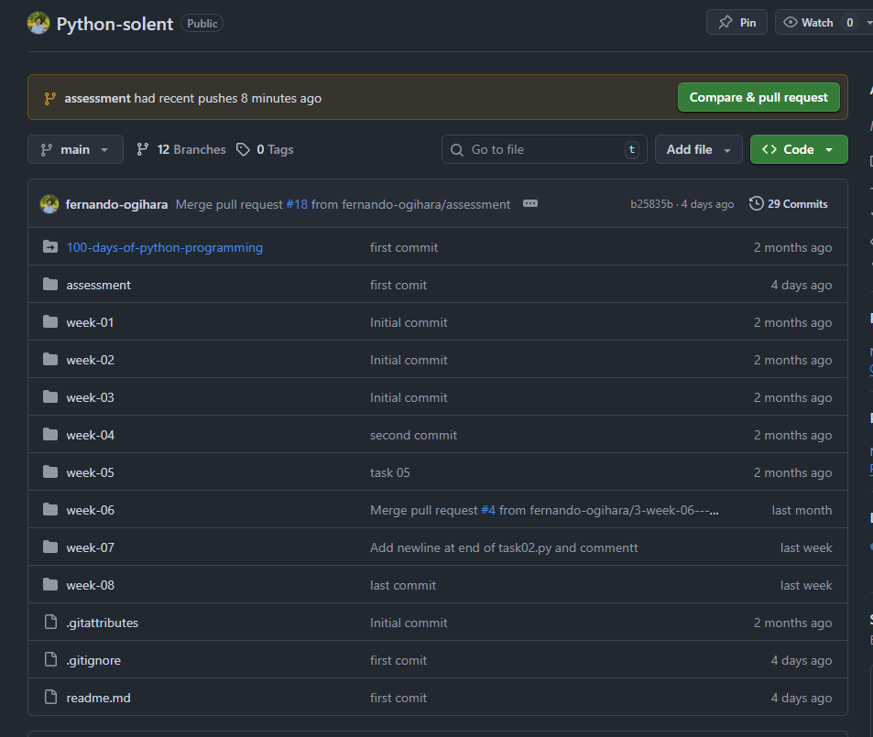
Figure 1: Github repository image 1

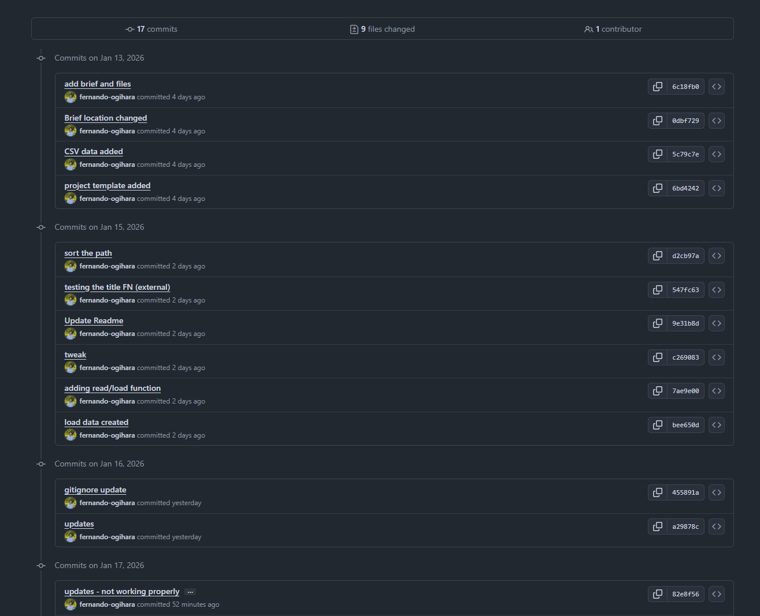
Figure 2: Github repository image 2

3 - Class Diagram

Figure 3: Class diagram illustration

4 - Evidence of Conforming to PEP8 Standards

Following the coding best practices, below I can show that my code is properly build and no errors are present in the workspace.
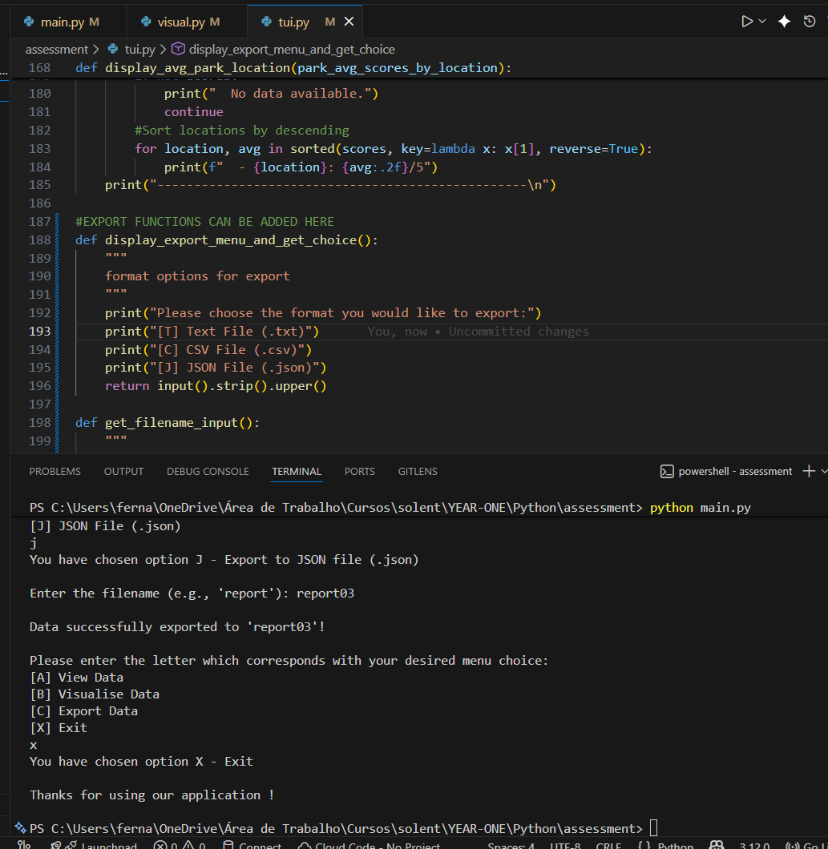
Figure 4: PEP8 standards image 1

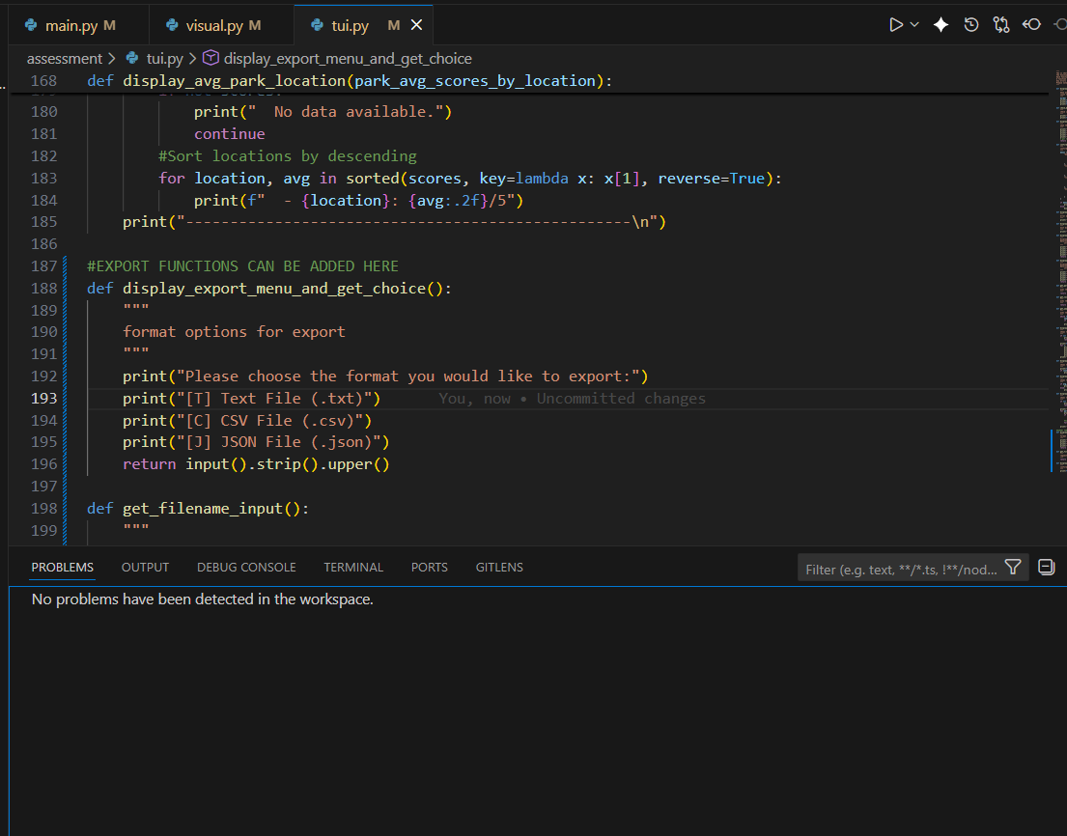
Figure 5: PEP8 standards image 2

5 – References

https://www.python.org/
https://www.w3schools.com/python/
https://www.codecademy.com/catalog/language/python
https://www.youtube.com/@cursoemvideo
https://www.udemy.com/
https://www.lucidchart.com/pages
https://github.com/

